**PROTEUS**

**LAB # 01**



**Spring 2023**

**CSE-206L Electronic Circuits Lab**

Submitted by: **Ali Asghar**

Registration No.: **21PWCSE2059**

Class Section: **C**

“On my honor, as student of University of Engineering and Technology, I have neither given nor received unauthorized assistance on this academic work.”

Submitted to:

**Engr. Abdullah Hamid**

**Date**: 7th July 2023

**Department of Computer Systems Engineering**

**University of Engineering and Technology, Peshawar**

**OBJECTIVES:**

* To learn the basics of Proteus Software and also we will make and simulate some basic circuits.

**THEORY:**

**PROTEUS:**

The Proteus Design Suite is a proprietary software tool suite used primarily for electronic design automation. The software is used mainly by electronic design engineers and technicians to create schematics and electronic prints for manufacturing printed circuit boards.

**Main Window:**

Main window when opened.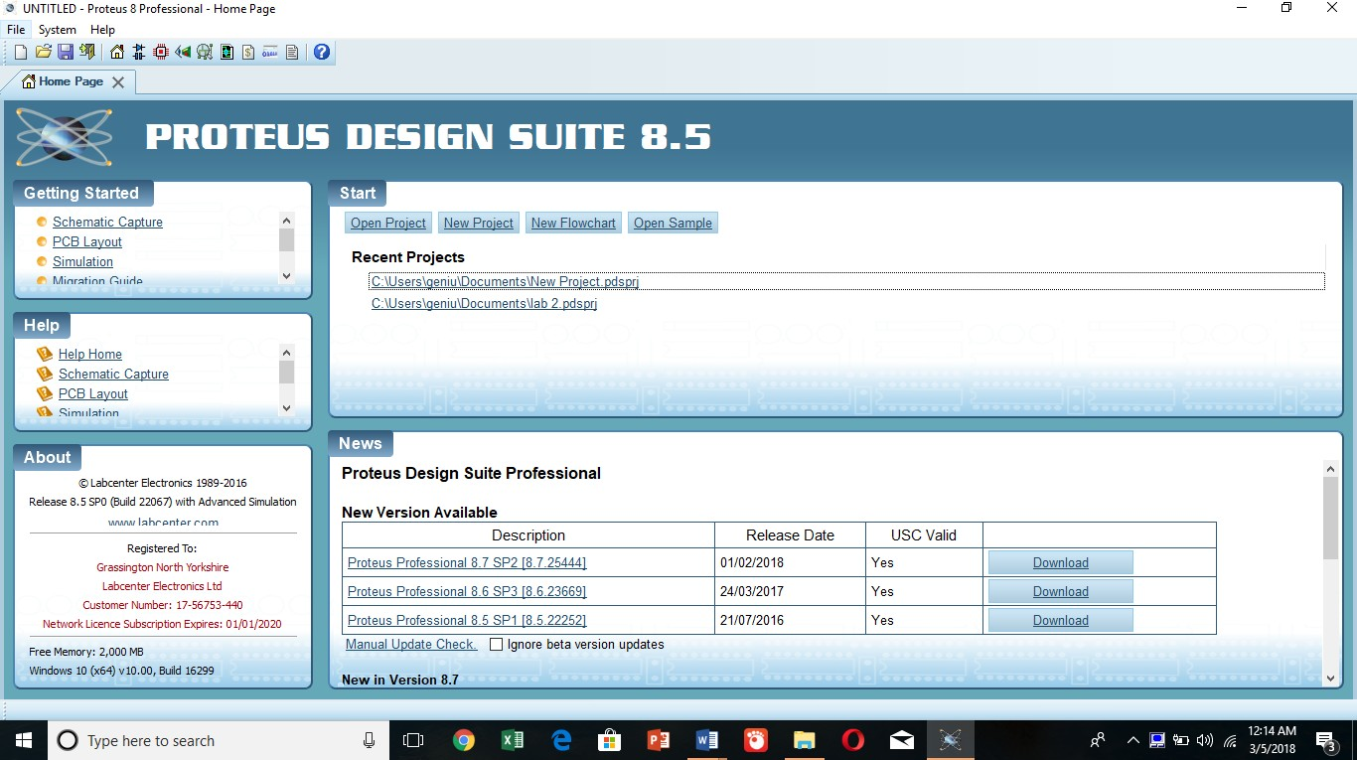

**To Open A New Project:**

To open a new project, select circled icon in the given image…

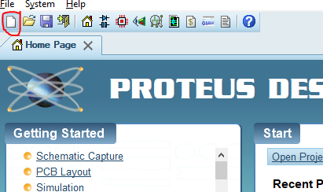

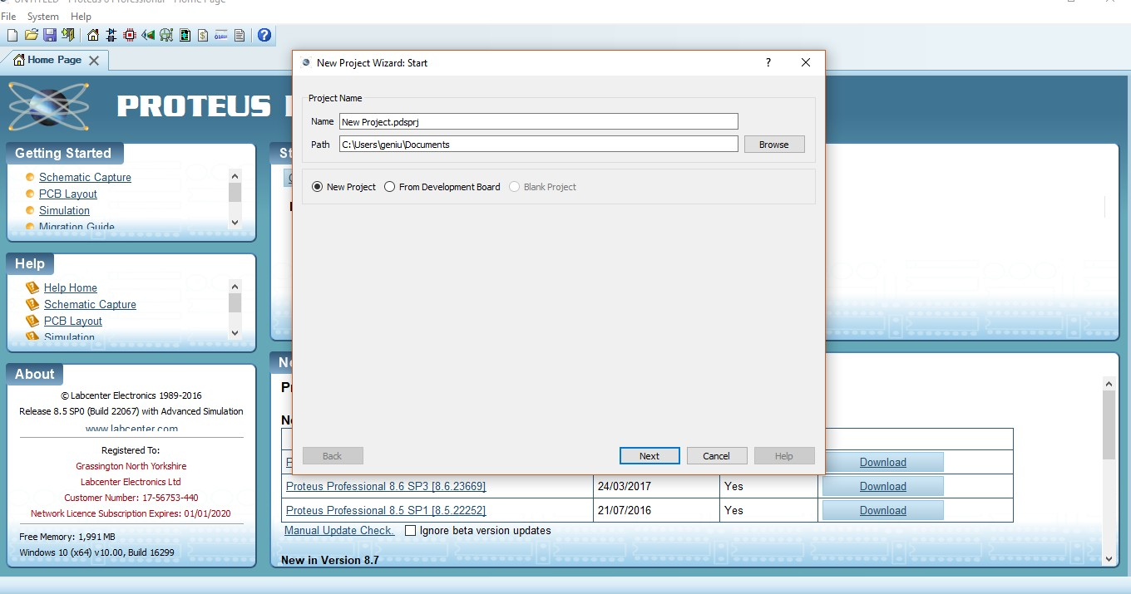After that we will get this window

After that select Potrait A4 from the options…

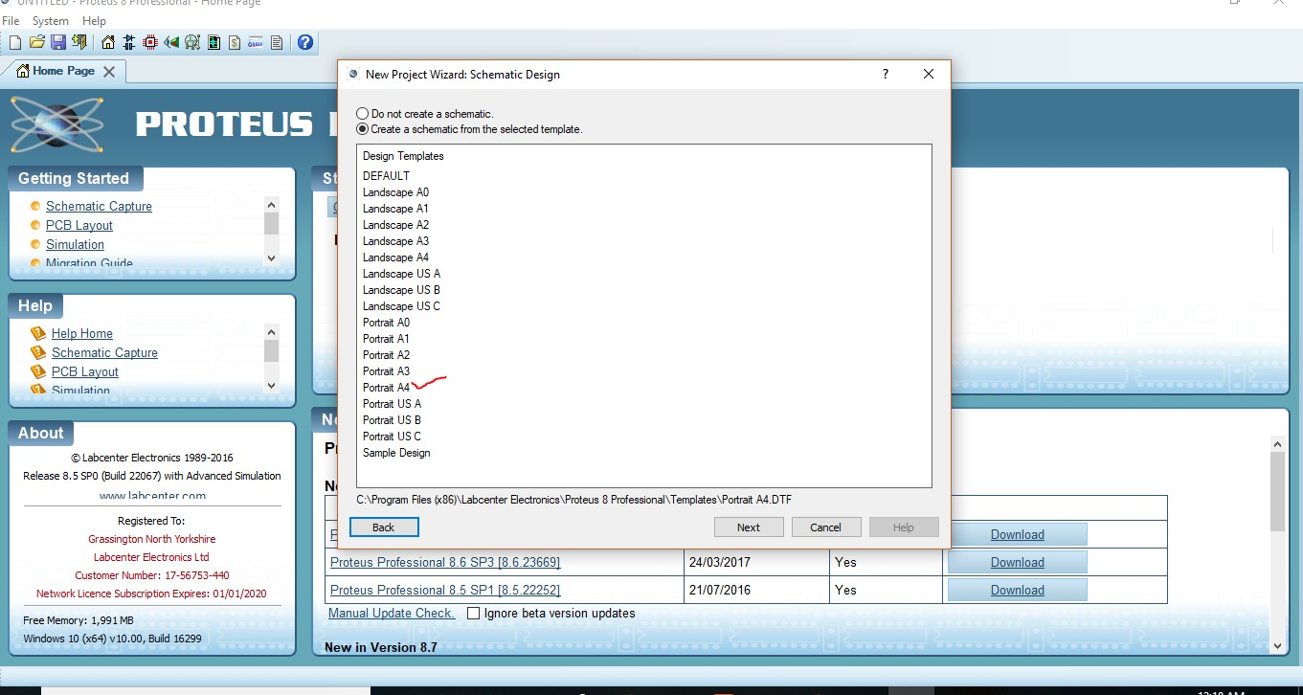

After that select Single Eurocad (2 layer).

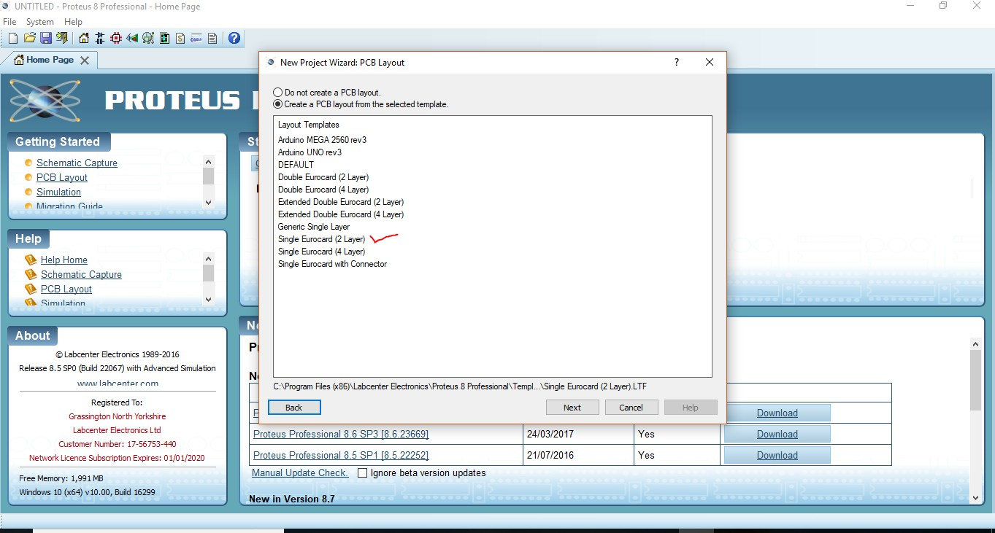

So, after finishing this we will get this screen.

If we want to Design a PCB layout we have to select this option (in the red).

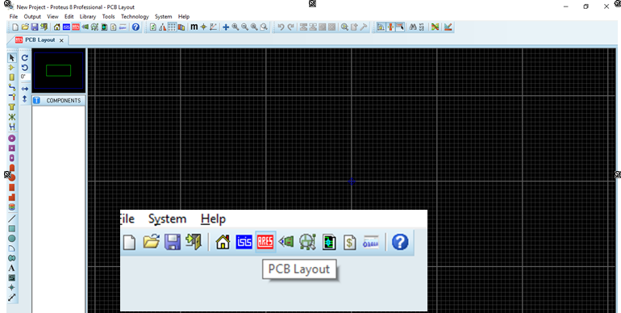

If we want to Design Schematic we have to select this option (in the blue).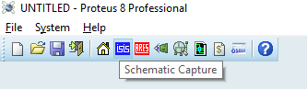

**Component Mode:**

For designing a circuit we need components which can be selected from here below the arrow.

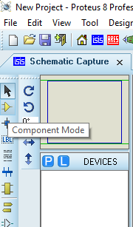

We will get this window to select or search for a specific component type the keyword of that component. We can select it form the category list or can search it directly by typing the keyword of element we want to search. E.g we have searched for resistor. Keyword is res.

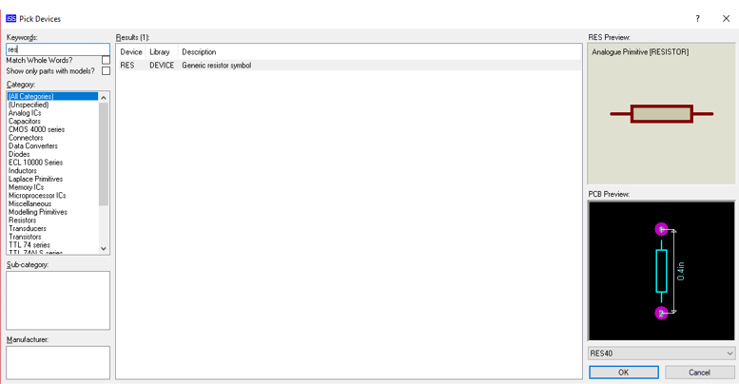

For selecting battery

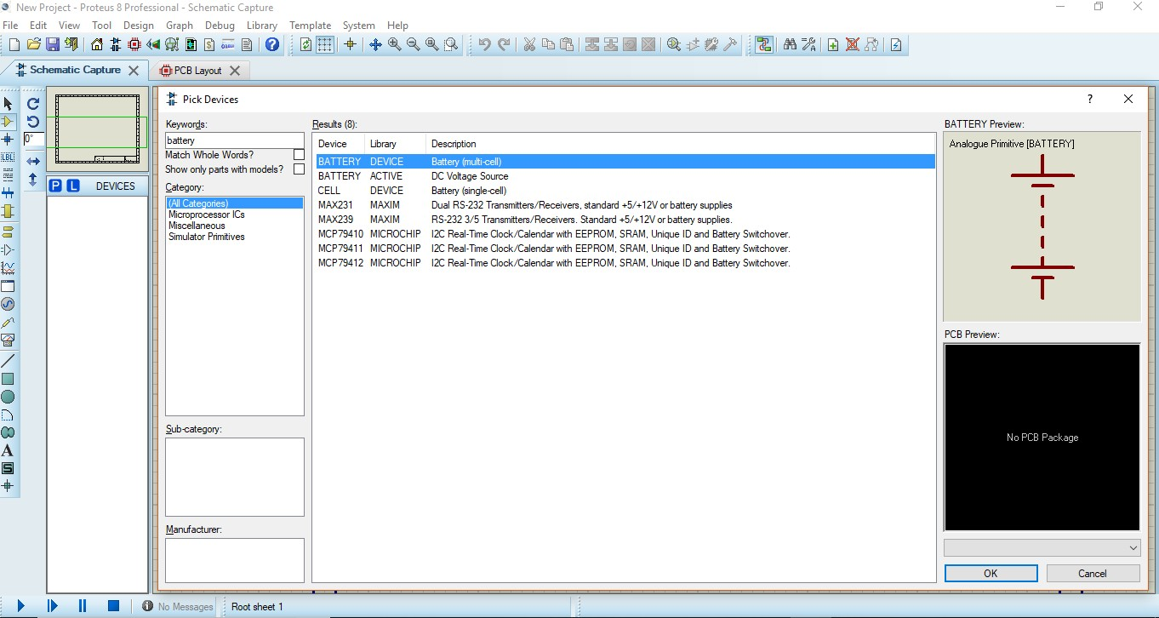

For selecting ground go to the Terminal Mode as shown below and Select GROUND

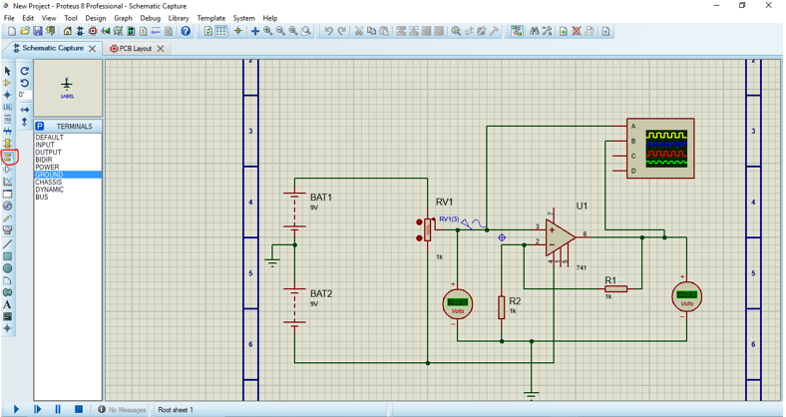

For potentiometer go to component mode and type HG

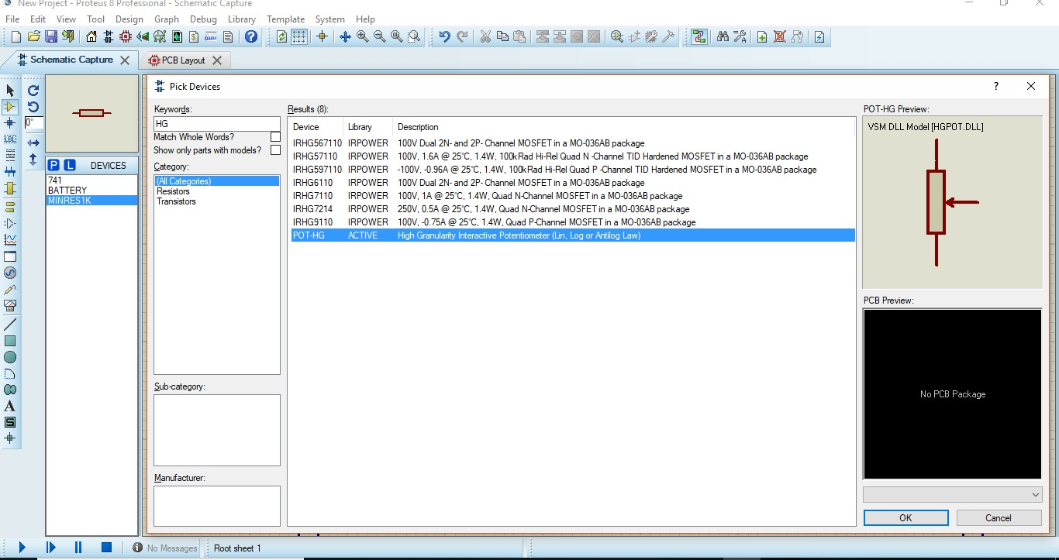

For OpAmp type 741 or any model number

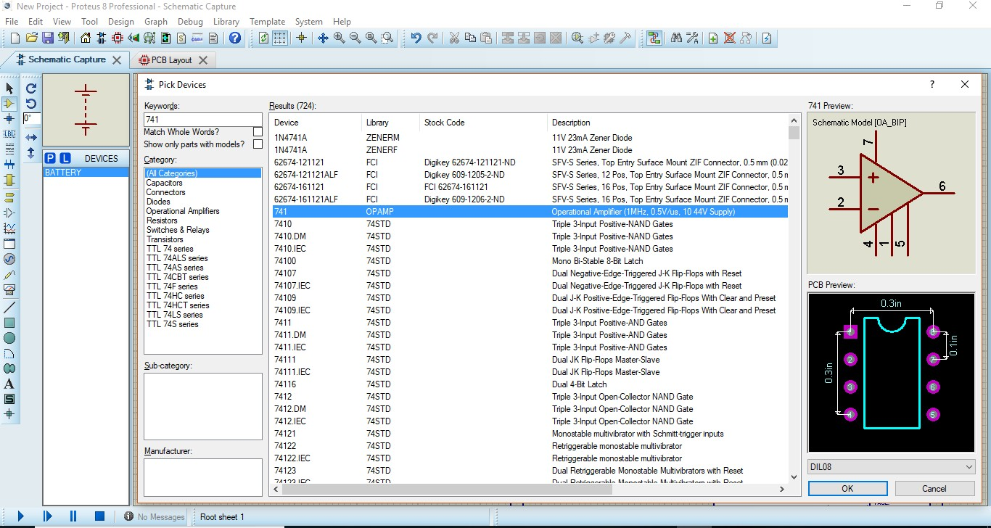

You can select DC or Sine in Generator mode as shown below

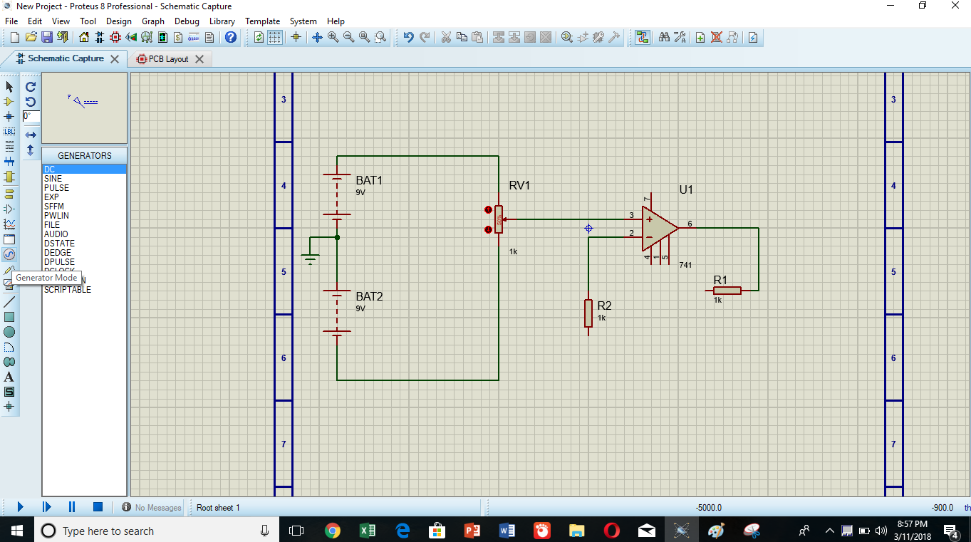

Click on the arrow in the bottom left for simulation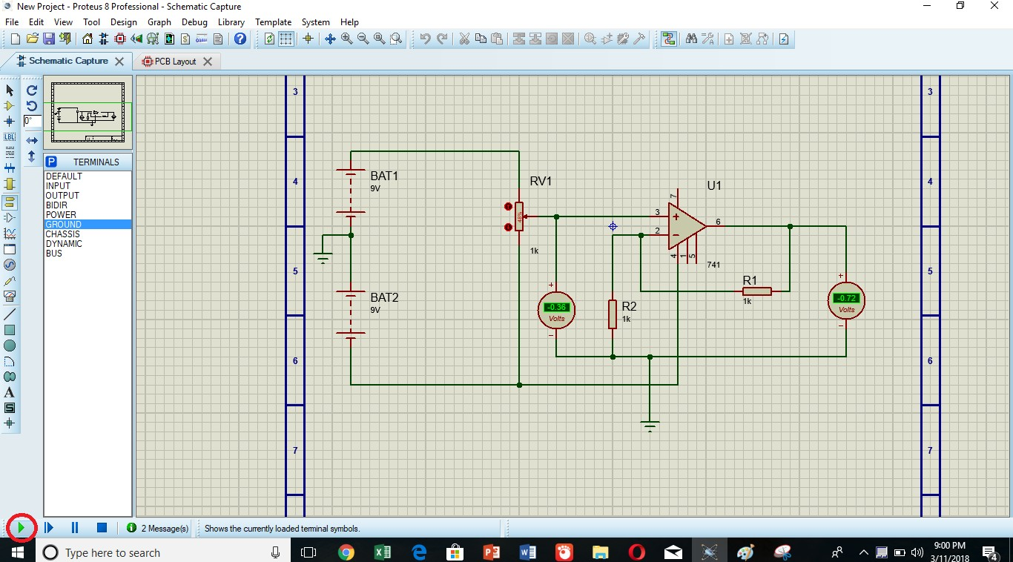

Now if you want to see the waves on oscilloscope you can select it from Instruments where you can also get voltmeter, ammeter etc

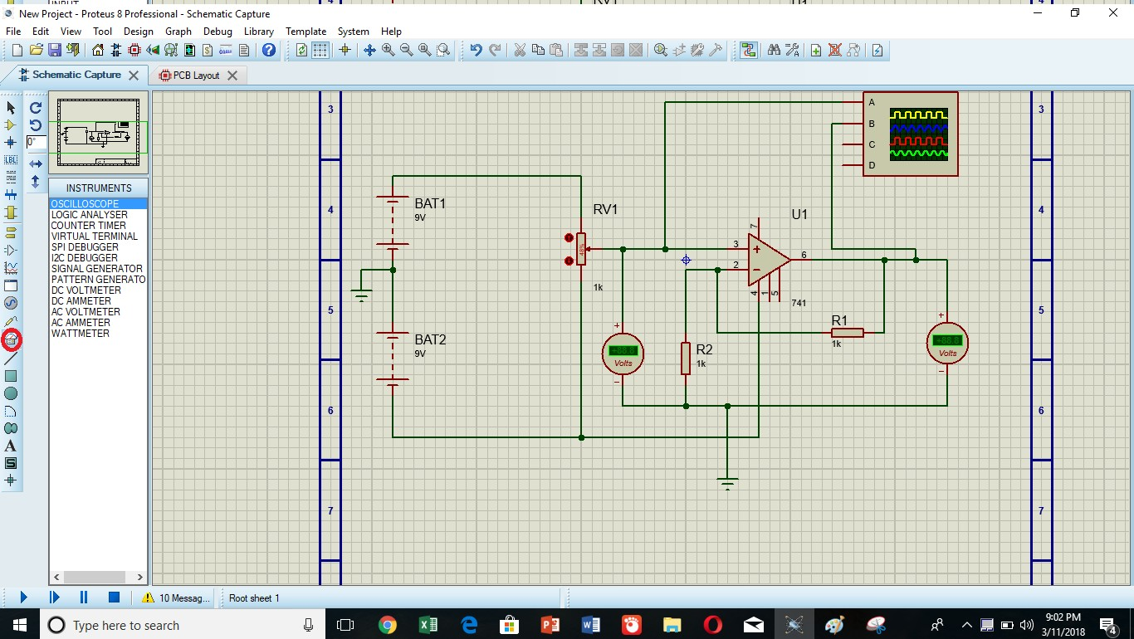

Here is the oscilloscope simulation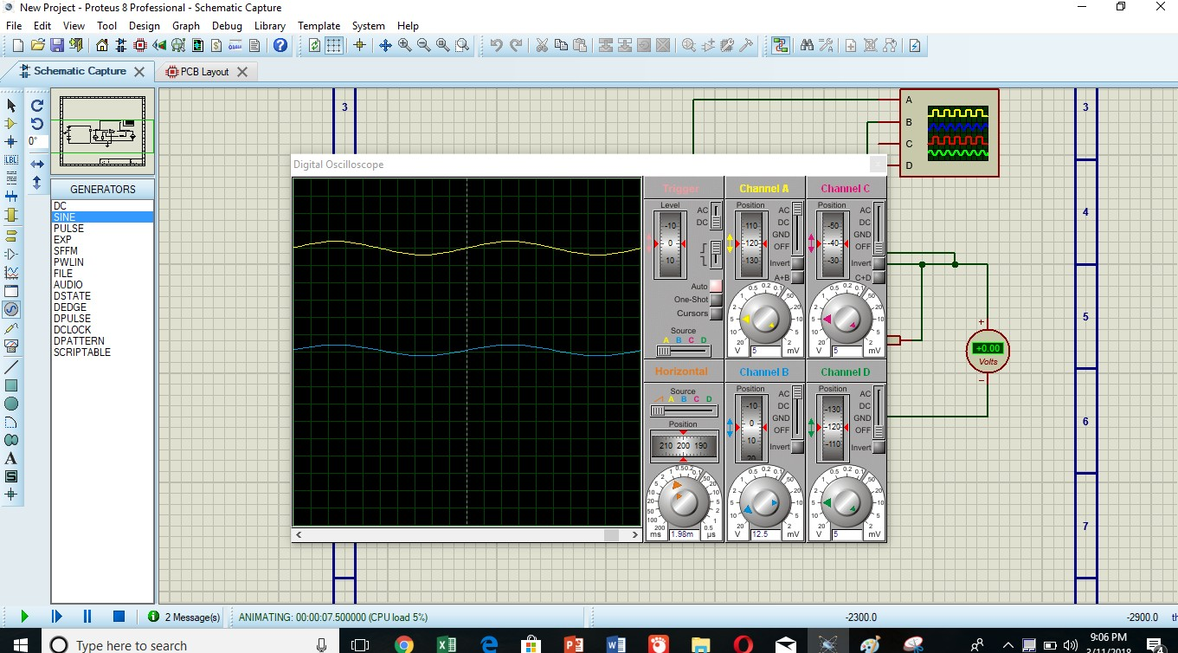

For PCB layout go to tools and click on auto placer window and select all components then press ok

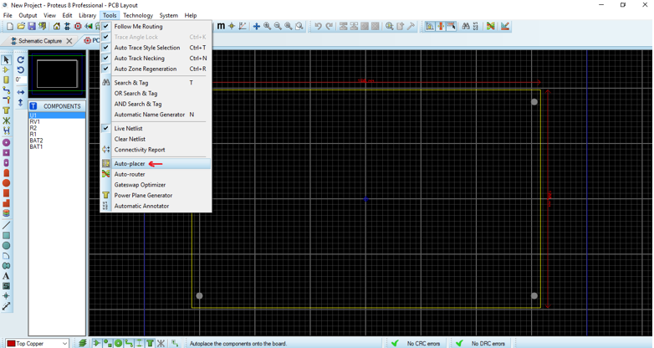

Now for routing purpose go to tools and select auto router

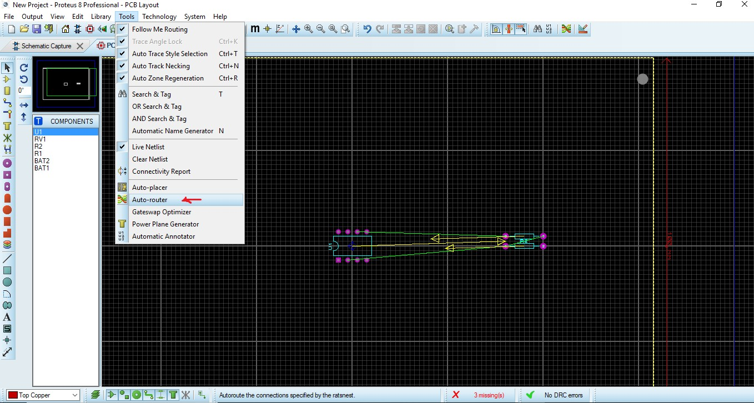

Click on begin routing

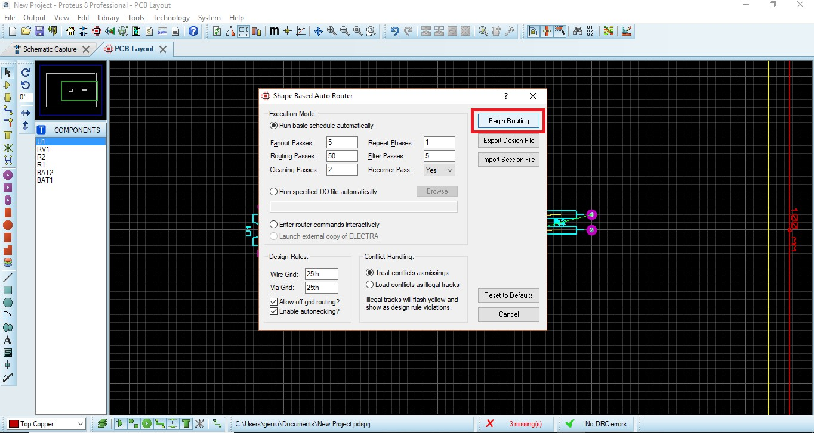

You will get the output result

